SQL Exploratory Data Analysis of E-Commerce Sales Data

Overview
This project was carried out as part of the Decode Labs Data Analytics Internship Program and focused on analyzing an e-commerce sales dataset using Microsoft SQL Server. The aim of the project was to extract meaningful business insights from transactional data by applying SQL queries and functions. Through data retrieval, aggregation, filtering, and summarization techniques, patterns relating to sales performance, customer behavior, product demand, payment preferences, and referral sources were identified.
Various SQL functions and clauses were utilized to answer key business questions and support data-driven decision-making.

Objectives
The objectives of this analysis were to:
- Identify products that contribute the most to sales revenue.
- Determine customers with the highest revenue contribution.
- Examine customer payment method preferences.
- Evaluate the distribution of order statuses.
- Analyze revenue trends over time.
- Identify the referral source generating the highest sales revenue.
- Generate actionable business insights and recommendations.
Dataset Description
The dataset was provided by Decode Labs and contains transactional information including:
- Order ID
- Date
- CustomerID
- Product
- Quantity
- Unit Price
- Shipping Address
- Payment Method
- Order Status
- Tracking Number
- Items In Cart
- Coupon Code
- Referral Source
- Total Price

Data Preparation
Before the analysis was conducted, the dataset was cleaned using Microsoft Excel to ensure data quality and consistency. The cleaning process involved handling missing values, checking for duplicate records, and standardizing data formats. The cleaned dataset was then imported into Microsoft SQL Server for analysis.

Analysis Process
A database named "E-Commerce Sales Data" was created in Microsoft SQL Server, and the cleaned dataset was imported into the [dbo].[Cleaned Data$] table.
Several SQL clauses and functions were applied throughout the analysis, including:
- SELECT
- FROM
- GROUP BY
- ORDER BY
- ROUND
- DATENAME
- COUNT()
- SUM()
- AVG()
These functions were used to retrieve, summarize, and aggregate data in order to answer business questions and uncover meaningful insights.

Summary Statistics
The following key metrics were calculated using SQL queries:
- Total Revenue: ₦1,264,761.96
- Average Order Value: ₦1,053.97
- Total Orders: 1,200
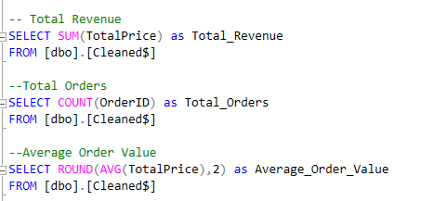
Interpretation: The dataset contains 1,200 customer orders that generated a total revenue of ₦1,264,761.96. The average order value was ₦1,053.97, which indicates that customers spent approximately ₦1,054 per transaction on average.

The analysis questions, queries, outputs and interpretations that were used to analyze this dataset are;
- Which products generate high sales revenue?

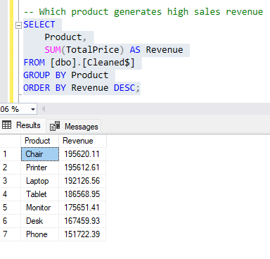
The analysis showed that Chair generated the highest sales revenue at ₦195,620.11. This was closely followed by Printer with ₦195,612.61 and Laptop with ₦192,126.56. On the other hand, Phone generated the lowest revenue at ₦151,722.39.

- Who are the customers that generate high sales revenue?

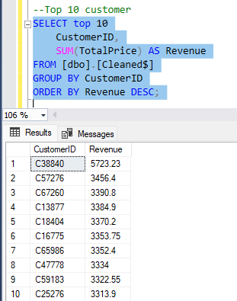

This analysis identified the top 10 customers that generate high sales revenue. These customers represent a significant portion of overall sales and may be considered high-value customers. Maintaining strong relationships with these customers can improve customer retention and long-term revenue growth.

- Which payment methods are most frequently used by customers?

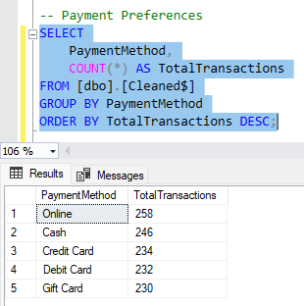

The results revealed that Online Payment was the most commonly used payment method with 258 orders. This was followed by Cash with 246 orders and Credit Card with 234 orders. Debit Card and Gift Card recorded 232 and 230 orders respectively.

- What percentage of orders are cancelled, delivered, pending, returned or shipped?

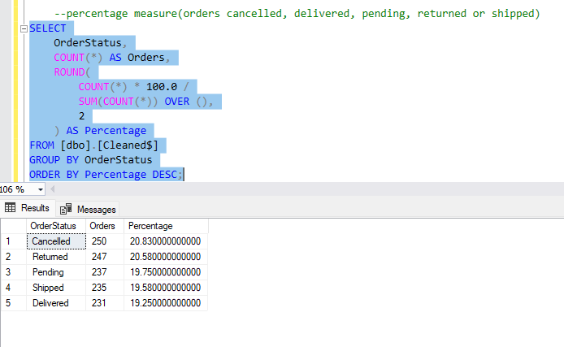

This analysis examined the percentage of orders that are cancelled, delivered, pending, returned or shipped. Cancelled orders were the highest at 250 (20.8%), followed by Returned at 247 (20.6%). Only 231 orders (19.2%) were successfully Delivered. The combined cancel and return rate of 41.4% is very high and is a key concern for the business.

- How has sales revenue changed over time?

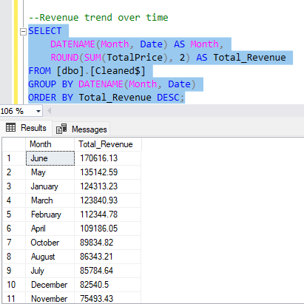

This analysis examined monthly revenue to see changes over time. June recorded the highest monthly revenue at ₦170,616.13, followed by May at ₦135,142.59 and January at ₦124,313.23. September had the lowest revenue at ₦69,321.65. Revenue was generally better in the first half of the year.

Which referral source generates the highest sales revenue?
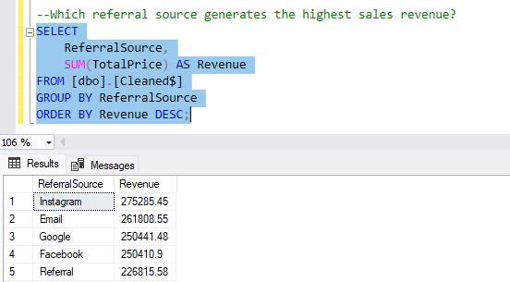
The results showed that Instagram generated the highest sales revenue among all referral sources. This suggests that customers acquired through Instagram made a greater contribution to overall sales compared to customers referred through other channels.

Key Findings
The analysis revealed several significant insights:
- Chairs generated the highest revenue among all products, contributing approximately ₦195.6K in sales. Printers and laptops also recorded strong revenue performance, making them key revenue-driving products.
- The top ten revenue-generating customers were identified, highlighting a group of high-value customers who play an important role in overall business performance.
- Online payment emerged as the most frequently used payment method, followed by cash, credit card, debit card, and gift card transactions.
- Approximately 41.4% of all orders were either cancelled or returned, representing a substantial operational and revenue challenge.
- Revenue performance peaked between May and June, reaching approximately ₦170.6K before experiencing a steady decline during the second half of the year.
- Instagram emerged as the highest revenue-generating referral source, highlighting the impact of social media marketing on business performance.

Recommendations
Based on the findings, the following recommendations are proposed:
- Products with strong revenue performance, particularly chairs, printers, and laptops, should receive increased marketing support and inventory allocation to maximize profitability. Lower-performing products such as desks and phones should be reviewed to determine factors affecting their sales performance.
- High-value customers should be targeted with personalized promotions, loyalty programs, and engagement strategies to encourage repeat purchases and strengthen customer retention.
- Since online and cash payments account for the majority of transactions, efforts should be made to maintain secure, reliable, and efficient payment systems to enhance customer experience.
- The high percentage of cancelled and returned orders should be investigated to identify underlying causes, such as delivery delays, product quality concerns, inaccurate product descriptions, or customer service issues.
- The factors responsible for the revenue increase observed between May and June should be examined and, where possible, replicated during lower-performing periods to improve overall sales performance.
- Since Instagram generated the highest sales revenue, the business should consider increasing its marketing activities on the platform through targeted advertising campaigns, influencer collaborations, promotional content, and customer engagement initiatives. The performance of other referral channels should also be evaluated to identify opportunities for growth and optimization.

Conclusion
The exploratory analysis successfully uncovered important trends and patterns within the e-commerce sales dataset. Revenue performance varied throughout the year, with the strongest results recorded between May and June. Chairs were identified as the leading revenue-generating product, while online payment remained the preferred transaction method among customers.
The analysis also highlighted a significant proportion of cancelled and returned orders, indicating opportunities for operational improvement. Additionally, the identification of top-performing customers provides valuable insights for customer retention and revenue growth initiatives.
Overall, the project demonstrates how data-driven analysis can be used to support strategic decision-making and improve business performance.

